Advantages and disadvantages about star, ring, and bus topologies

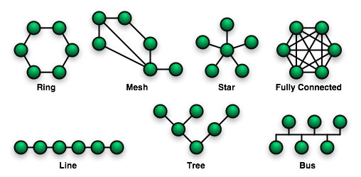

Bus Topology
Advantages - Simple to implement, all machines are 'daisy chained' which makes wiring as easy as stringing coax cable from one computer to the next and so on.
Disadvantages - Not very versatile when machines have to be moved, as rewiring part of the network is necessary. Not very fault tolerant, on some systems (10Base2) if one part of the bus is disconnected the whole segment of the network goes down. Not suitable for voice.
Ring Topology
Advantages - Fairly simple to wire. Quite fault tolerant, with a Token Ring network if the main ring is disconnected anywhere, the ring uses a loop back system to maintain ring integrity.
Disadvantages - It is only really used with Token Ring networks these days and it uses Type 1 cable, this is very bulky and is not really suitable for running voice. Again, moves and additions mean rewiring and re-routing cables.
Star Topology
Advantages - These days most buildings are cabled using a star topology with Cat 5e or Cat 6 cable. This gives the network a centralized wiring point which makes connecting and disconnecting machines as simple as plugging and unplugging an RJ45 connector in to a hub or switch (Ethernet, Token Ring and any other type of network or service that is required). It can also be used for voice, data, video and any low voltage application.

Disadvantages - Requires a centralized wiring point, which can be just a cabinet on the wall for small installations, or a dedicated air conditioned room with racks and cabinets in large office accommodation. On large installations the sheer bulk of cable coming back to the wiring closet can be difficult to control and keep tidy.

All of the traffic which transverses the network passes through the central hub. The hub acts as a signal booster or repeater which in turn allows the signal to travel greater distances. As a result of each machine connecting directly to the hub, the star topology is considered the easiest topology to design and implement. An advantage of the star topology is the simplicity of adding other machines. The primary disadvantage of the star topology is the hub is a single point of failure. If the hub were to fail the entire network would fail as a result of the hub being connected to every machine on the network.

